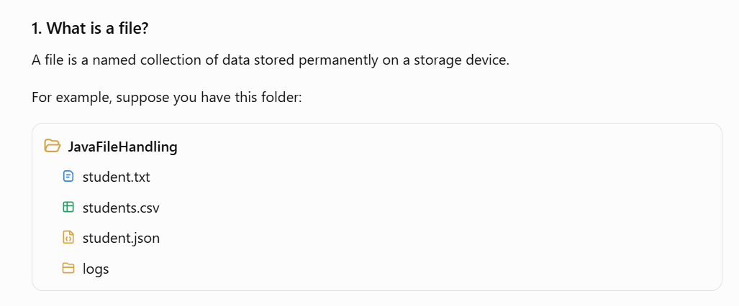
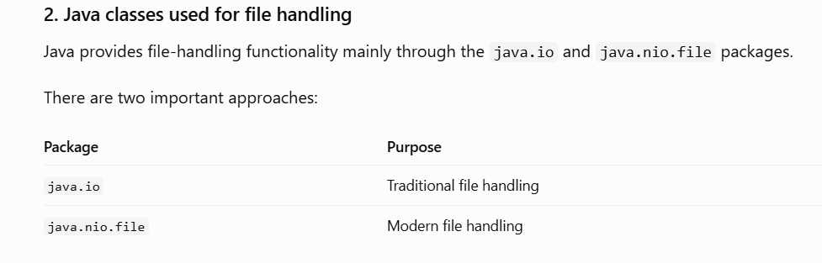
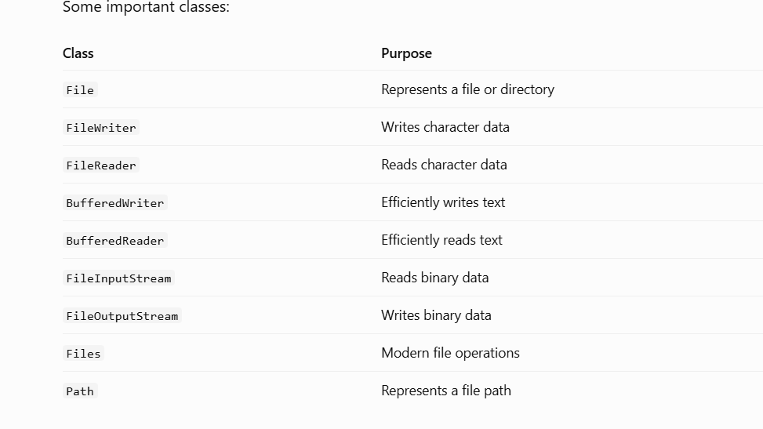
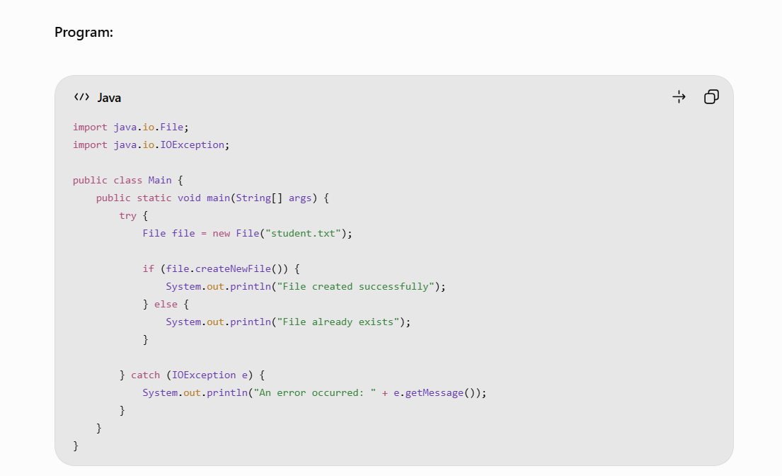

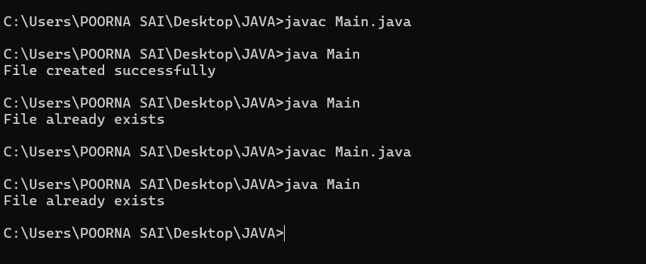

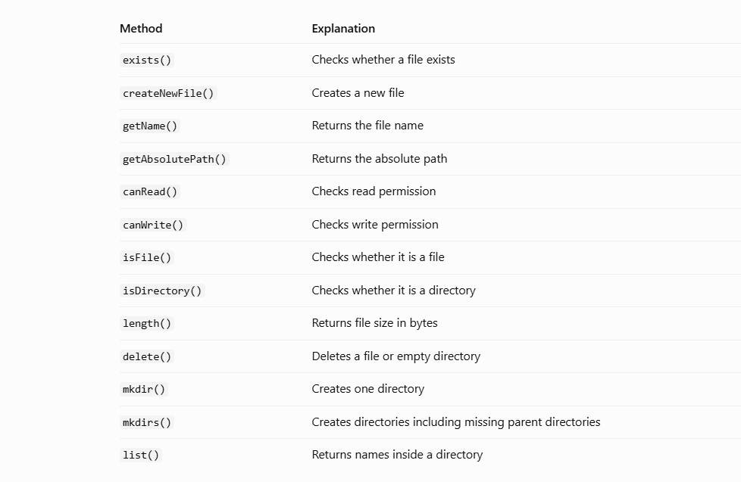
However with the help of File class alone we can’t write or update the file , so we need another class FileWriter .

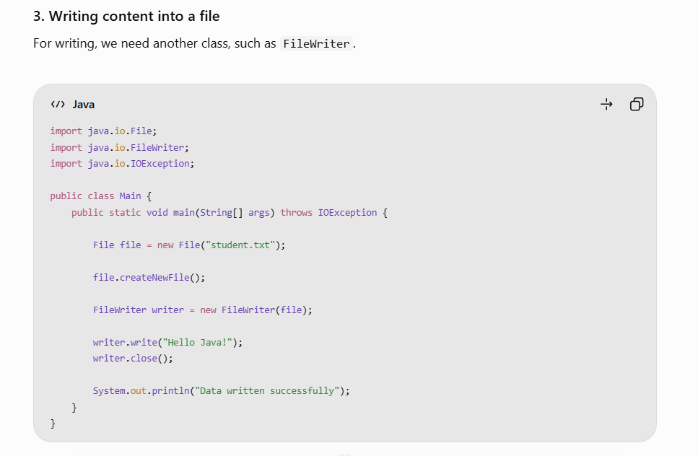
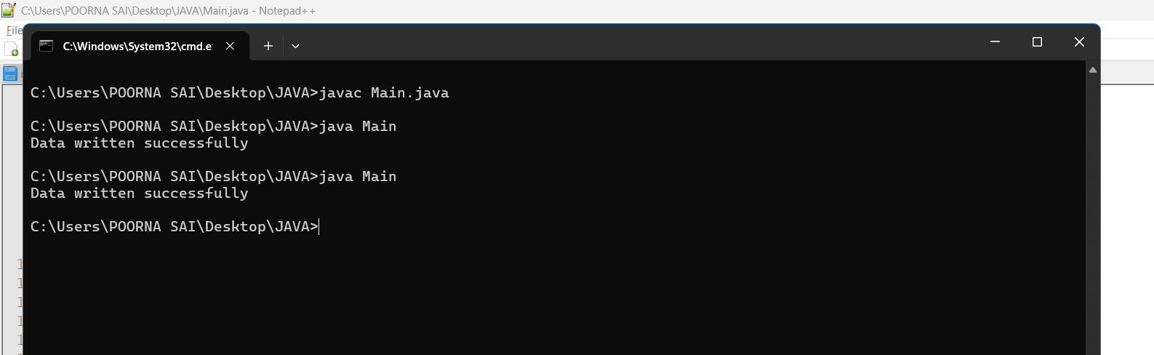

But it will override the content if you want to update the file by keeping the old data then we have to use another parameter :
FileWriter writer = new FileWriter("student.txt", true);
true → Adds content without removing existing content.
false → Overwrites existing content.
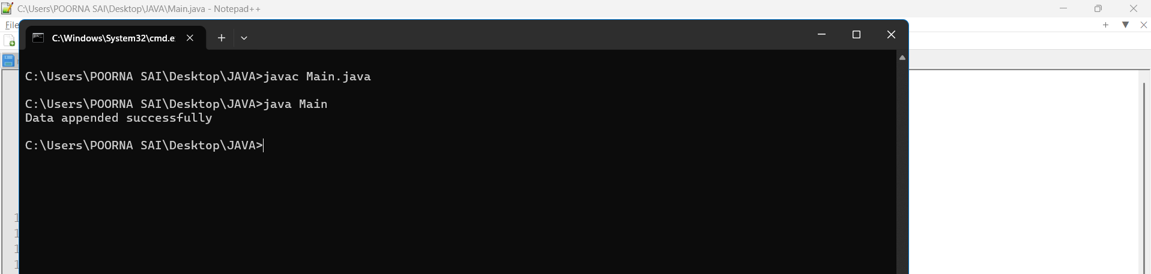

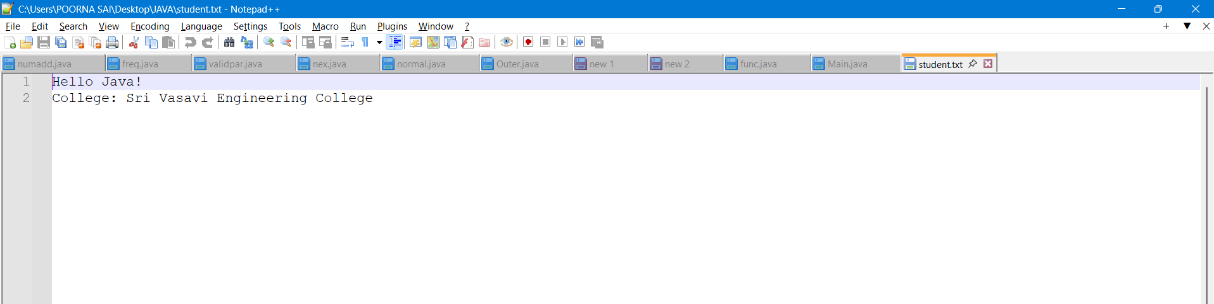

Using the FileReader for reading the content in the file.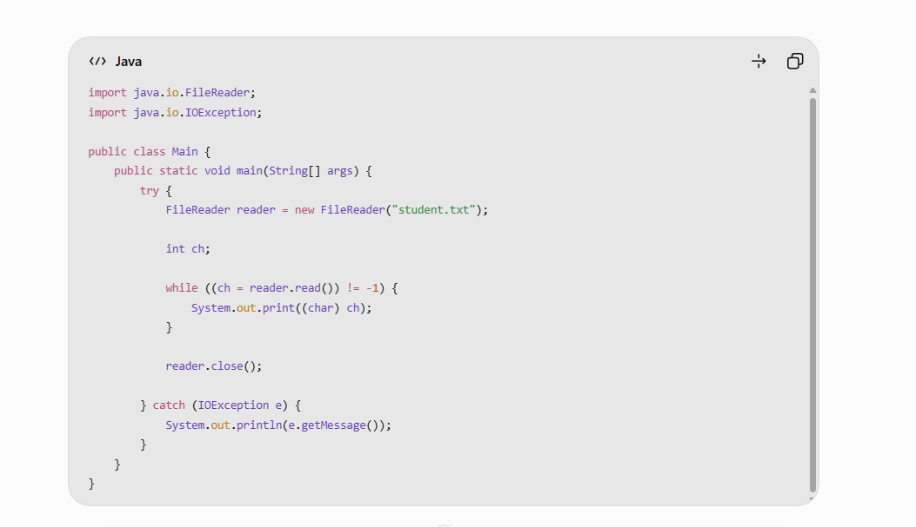
OUTPUT :
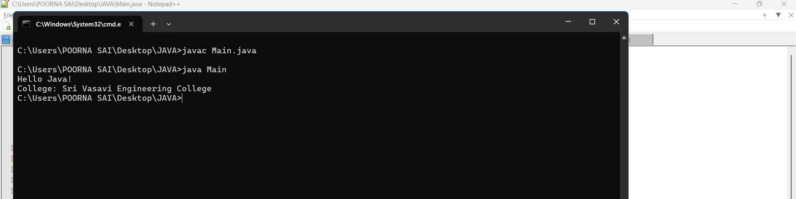

2. BufferedWriter
BufferedWriter is a wrapper around another Writer (such as FileWriter).
It uses an internal memory buffer to temporarily store characters before writing them to the file.

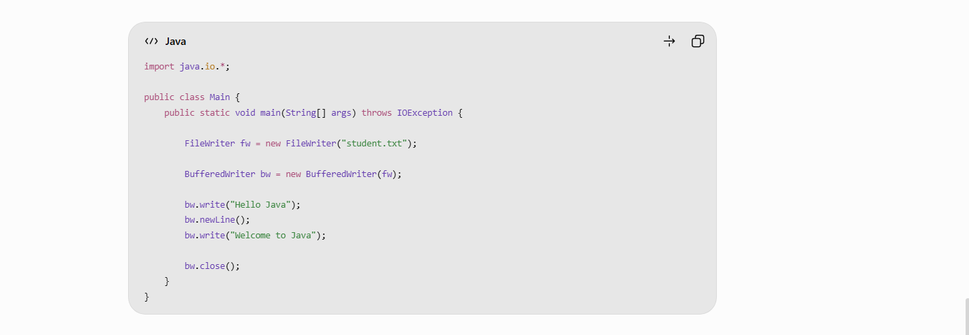






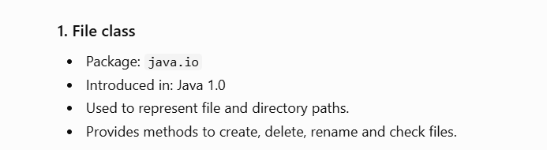

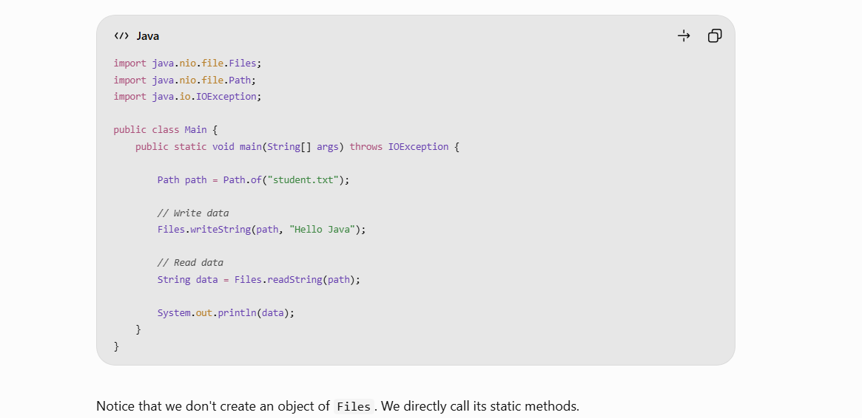

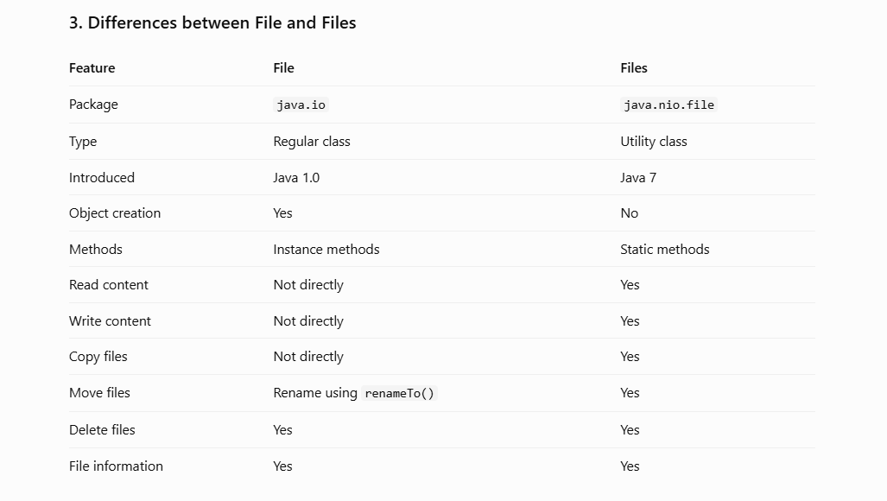

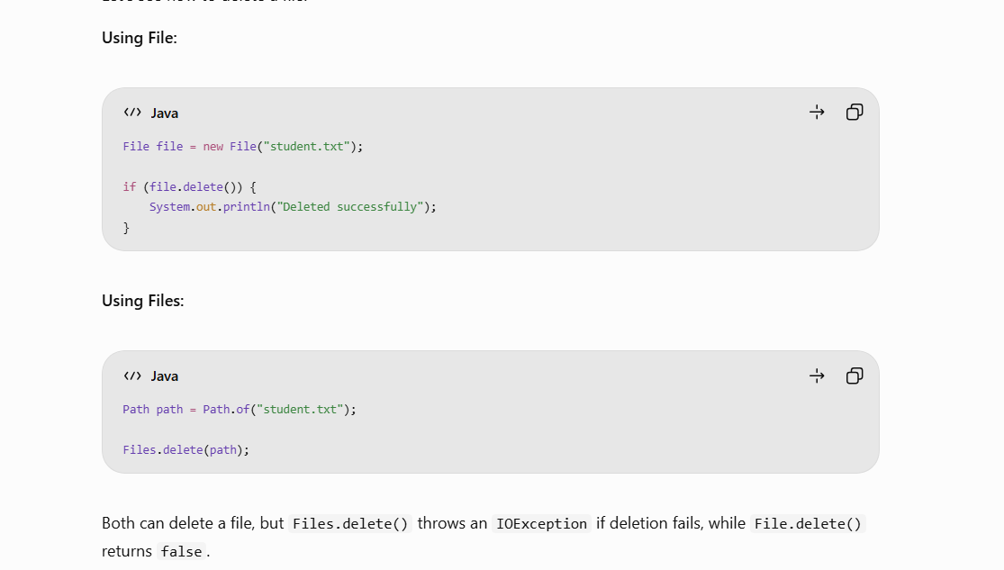
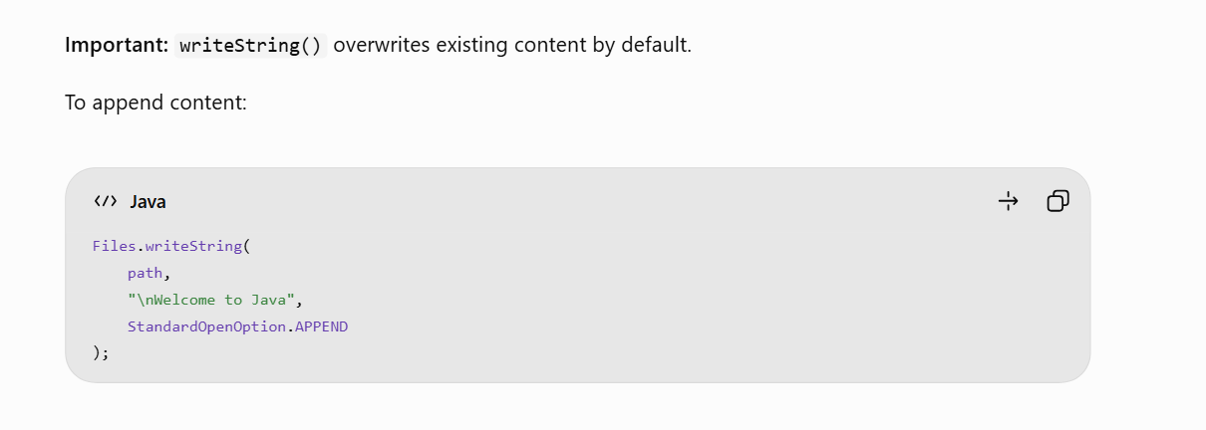
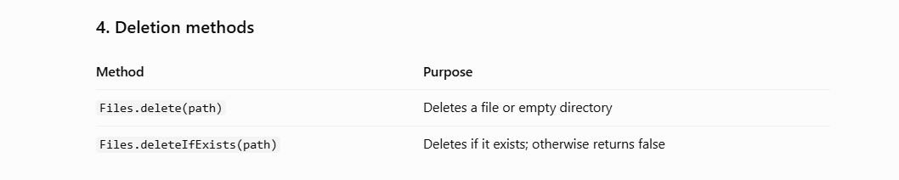
Paths.get() Vs Path.of() :-
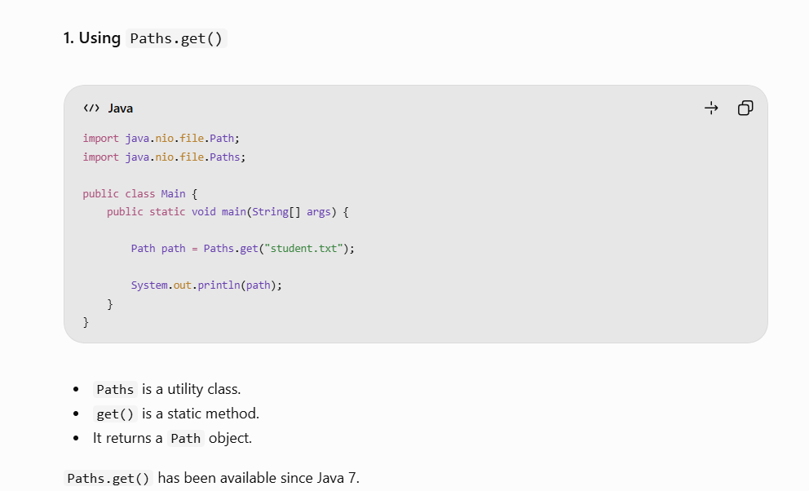

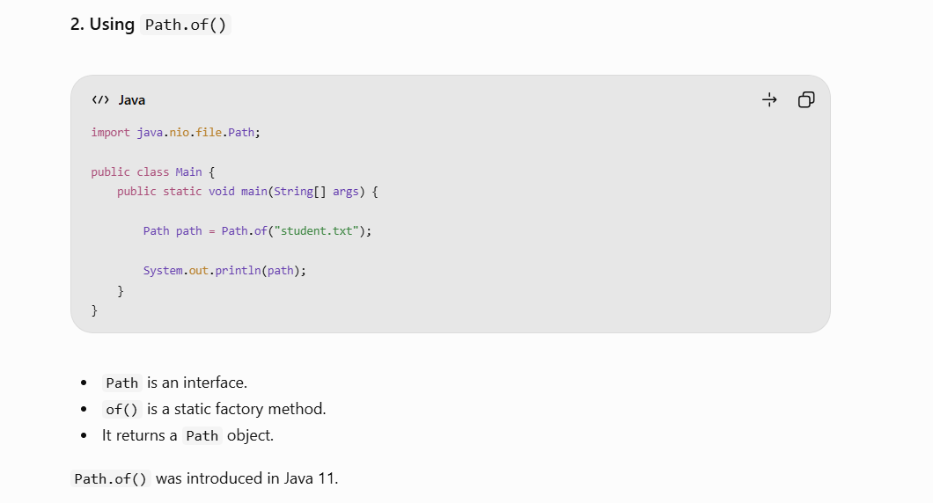

Important Differences : -


